OOP LAB ASSIGNMENT #09

ILF ALI MOMIN | CS221033

QUESTION 1 | Output

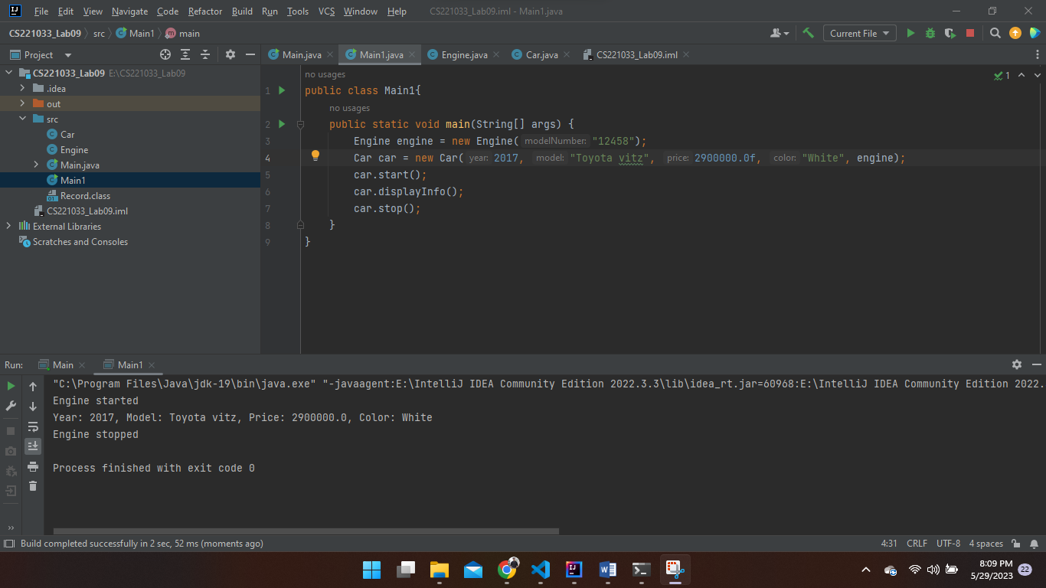

QUESTION 2 | Output